DHCP-Dynamic Host Configuration Protocol

If a computer had to get an IP address, it can be done by 2 ways
1.Static IP address assignment(manual)
2.Dynamic allocation through DHCP.

1.Static IP address assignment.
Here the user/network admin has to assign IP to a computer manually by providing IP, Subnet mask, Default gateway and DNS.
- It could be big problem when we are supposed add computers/client nodes to network continuously

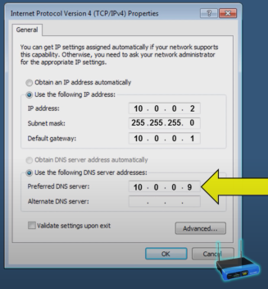

- Allocating same IP to different node leads to IP conflicts and nodes will be unreachable.

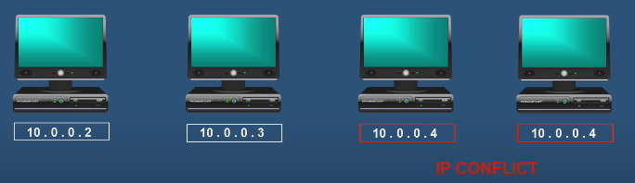

2. DHCP
DHCP Automatically allocates IP address to client node when it gets connected to network along
With, it also provides Subnet mask, Default gateway and DNS to client node in Autopilot.
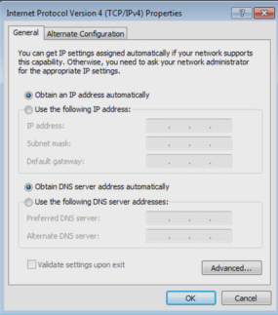
You have to make sure that, In client node it has to be “Obtain an IP address automatically” option to be selected.

Basic terminologies of DHCP.
1.Network/scope: Range of IP address a DHCP server can allocate/provide to clients.
Eg:
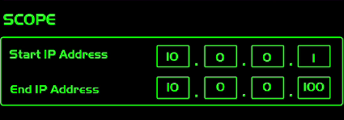
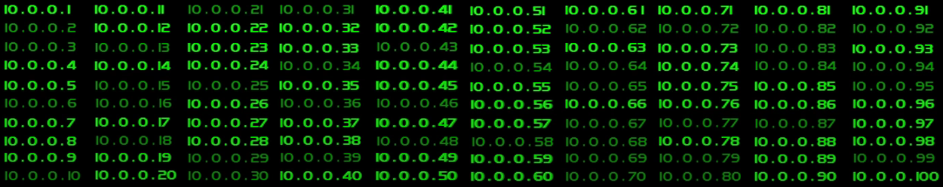
- As you can see this DHCP can provide 100 IP address automatically.
- Network admin can modify/change the range of scope.
2. Lease: Amount of time IP address assigned to a computer/node.
-> It can one day of two day etc.
->The main reason for lease is, Computer after getting its IP from DHCP, if it’s working continuously or after regular interval of time, the allocated IP for that computer will remain with it, if that computer is not in work or if its inactive for more than lease time, the IP address will be returned to DHCP and that IP address is ready to use for other computer/node.

Configuration yet to learn.

